**Home Assignment 1 – Wireshark, DNS, HTTP**

**Question 1:** The selected interface is Wi-Fi en0

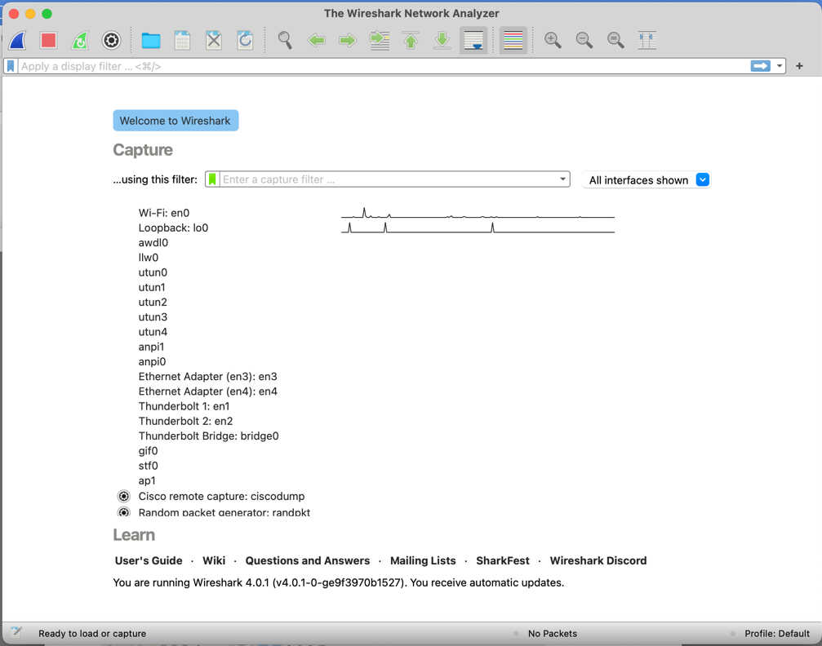

**Question 2**:

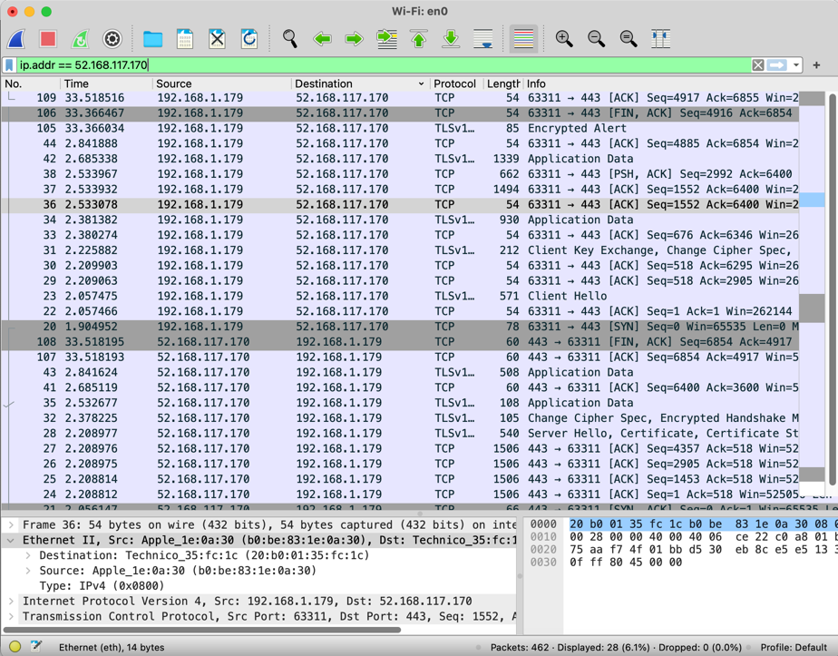  
  
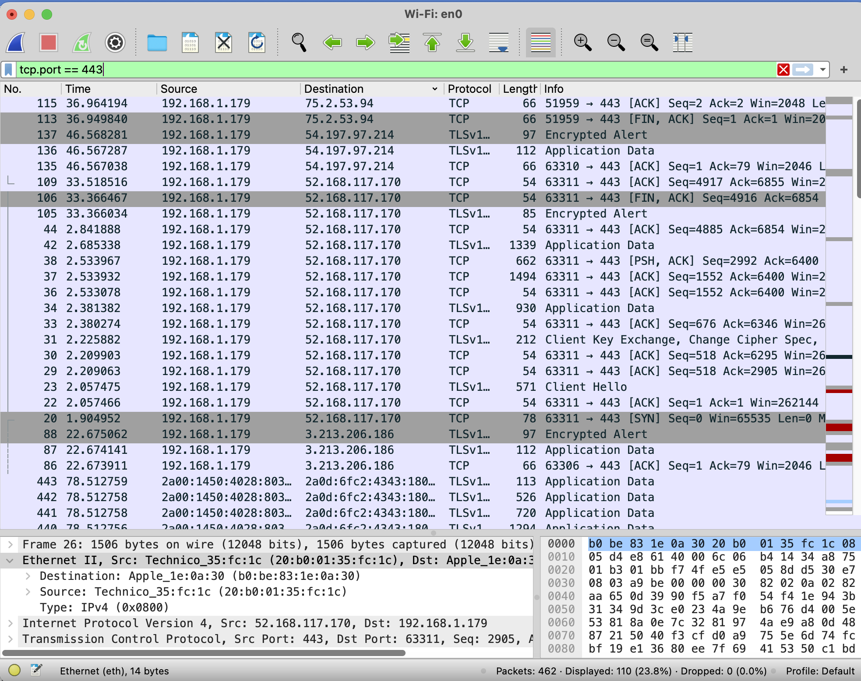

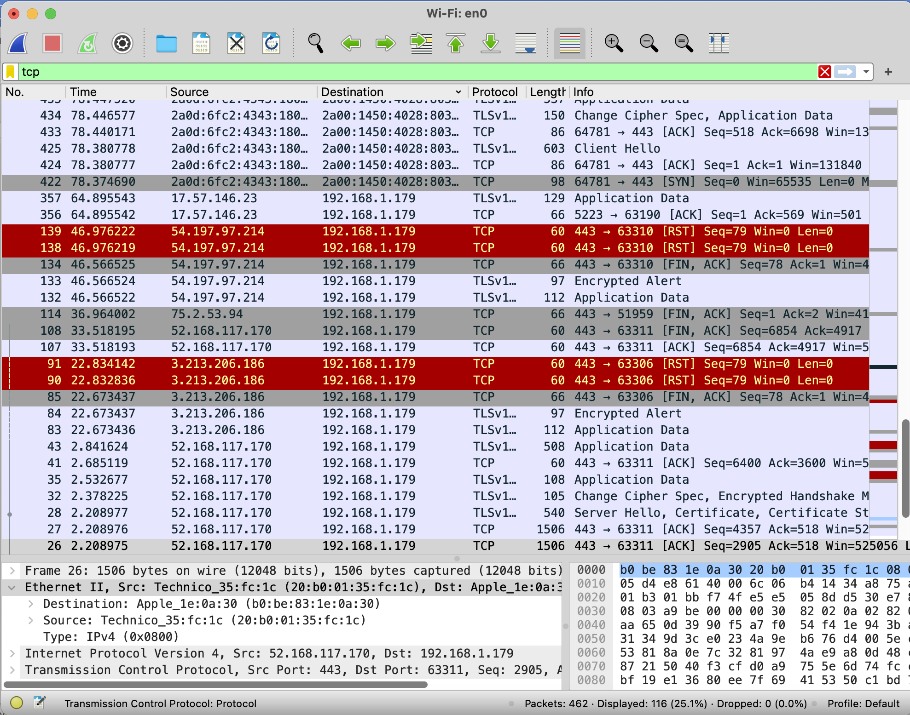

**Question 3:** the recording format is pcapng.

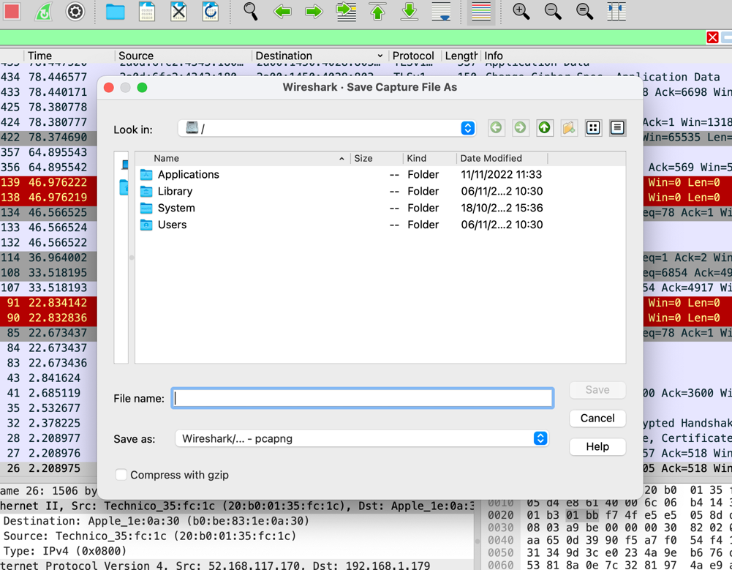

**Question 5:**

promiscuous mode is a mode of operation, as well as a security, monitoring, and administration technique. In promiscuous mode, a network device can intercept and read in its entirety each network packet that arrives.

**Question 6:** filtering in general through all kinds of protocols containing the string “unit”.

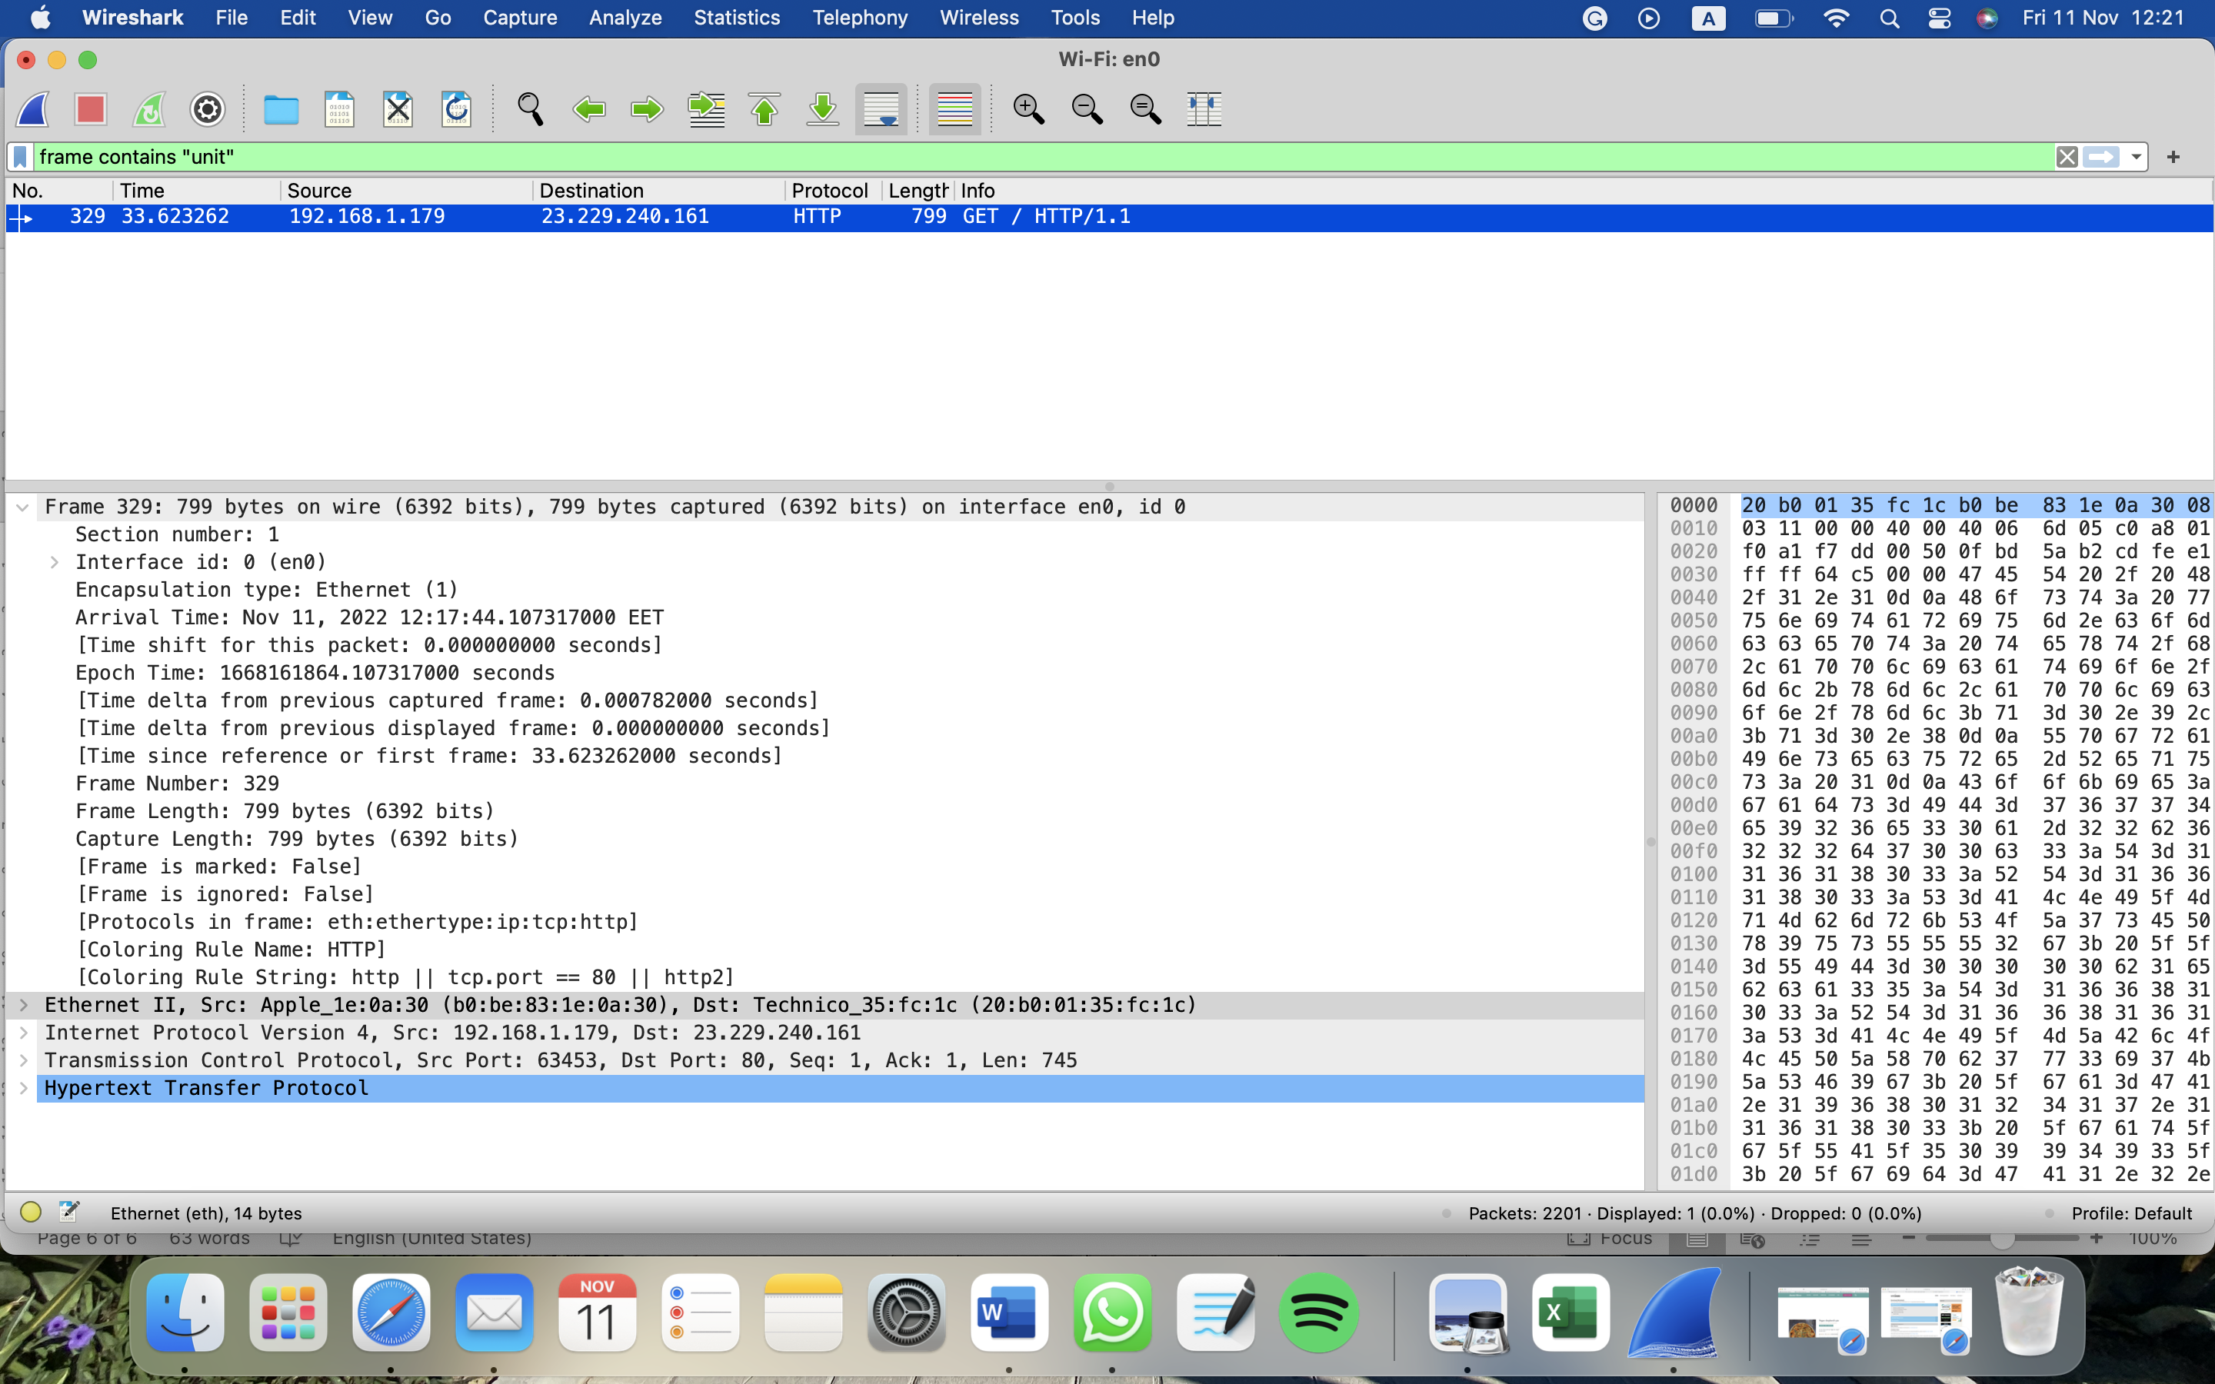

**Question 7:**

the GET packages are the requested packages and the replied packets are the ones on the next line in the picture below. We can identify each packet and whether it’s a replay or request by the arrows on the left side.  is a request and is the replay for the request packet.

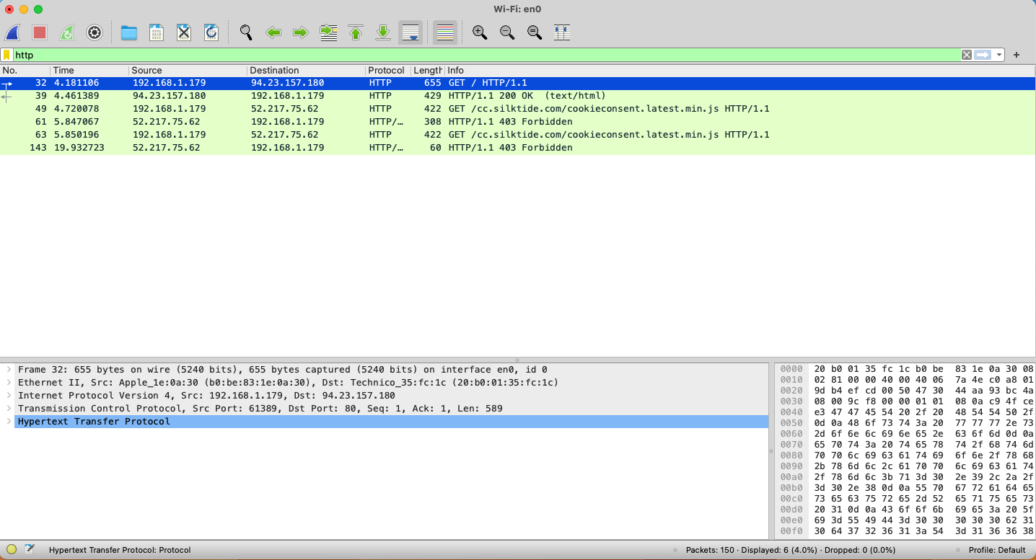

**Question 8:**

1. 4.461389 – 4.181106 = 0.280283 seconds
2. HTTP/1.1
3. Mac address: (20:b0:01:35:fc:1c)  
   IP address: 192.168.1.179
4. The replied packets are the ones on the next line in the picture
5. The request packet’s destination port is 80  
   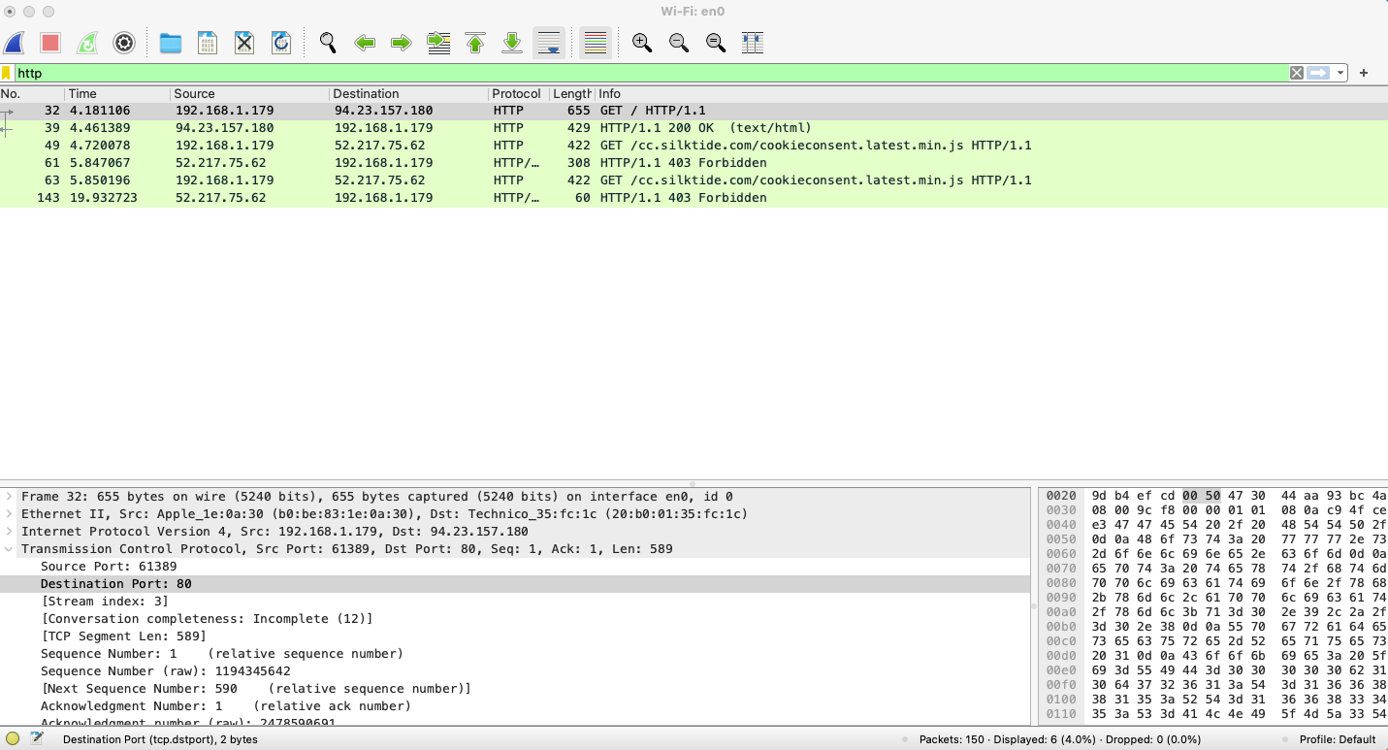



**Question 9:**

1. the response status code is 200.  
   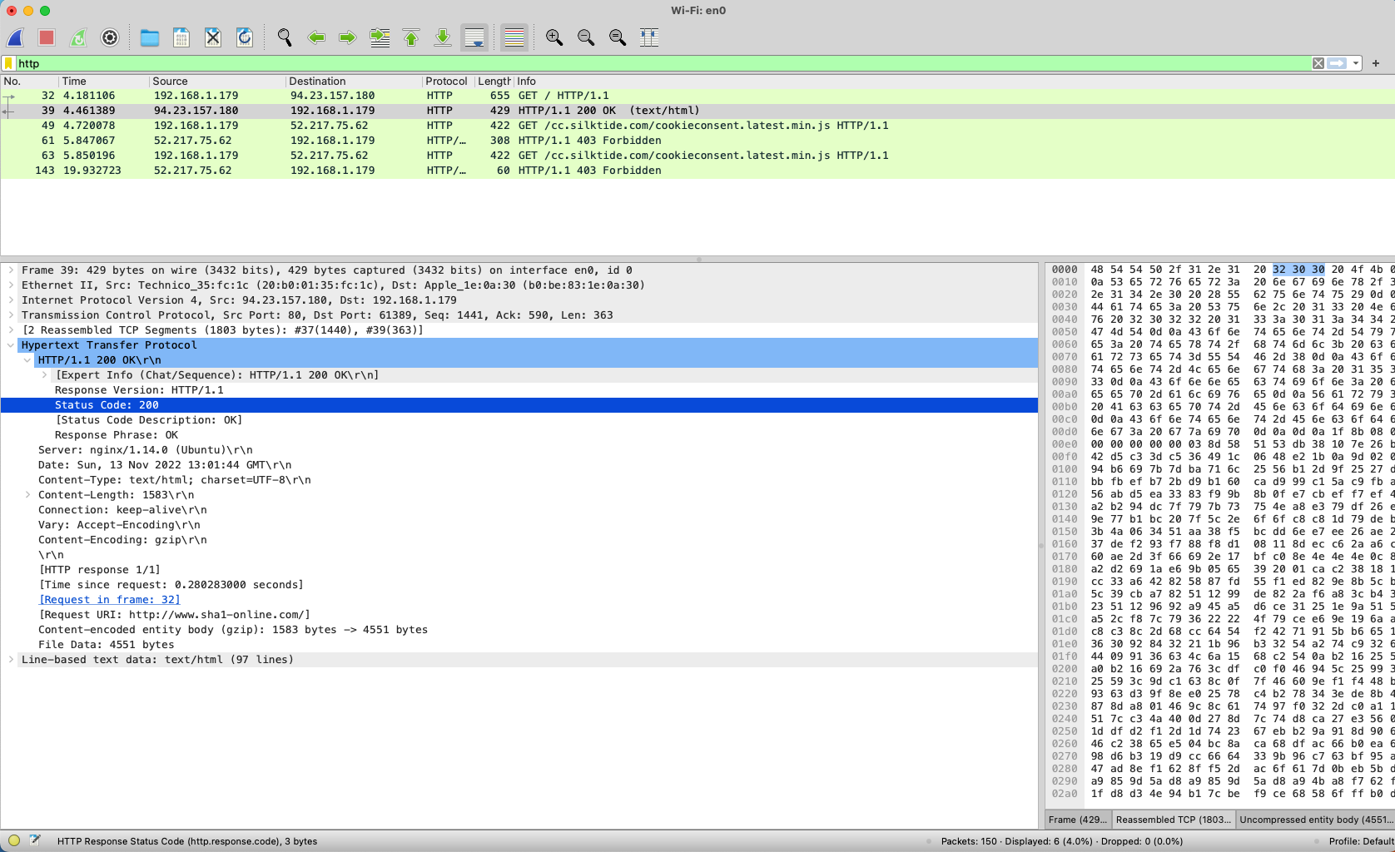



1. The response server is a kind of nginx and the server’s IP is 94.23.157.
2. There are 363 TCP segments necessary for this package.  
   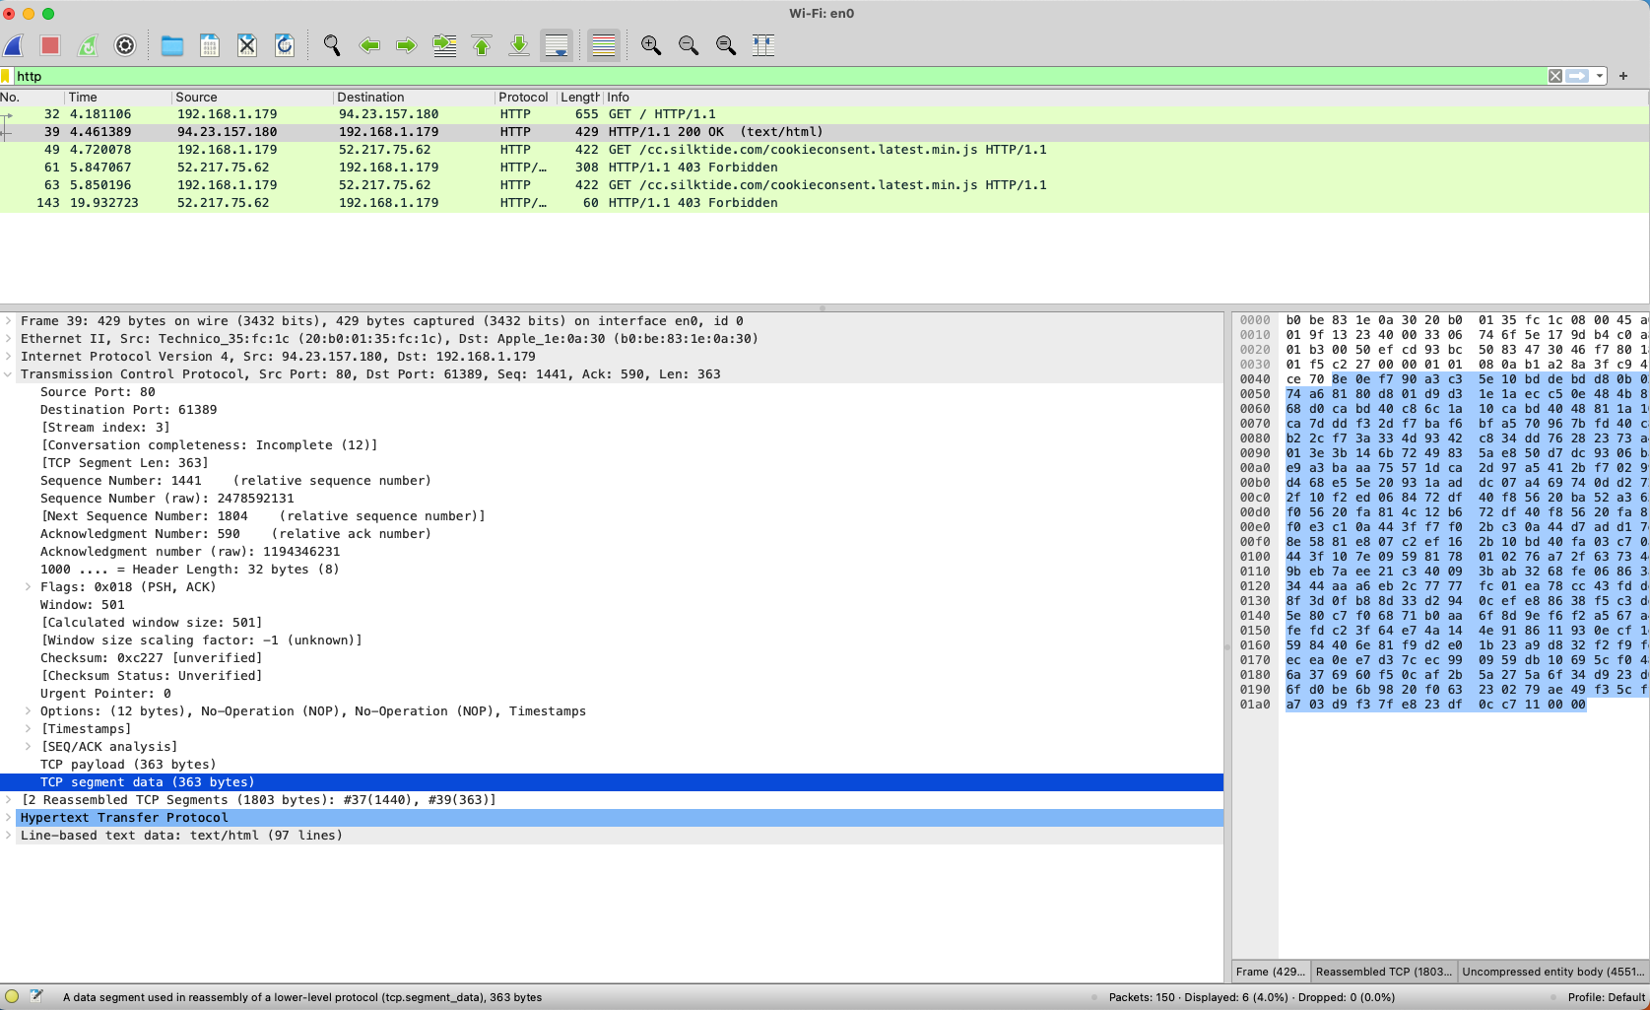
3. the connection type between the server and the client is a keep-alive connection. By default, HTTP connections close after each request. HTTP keep-alive is an instruction that allows a single TCP connection to remain open for multiple HTTP requests/responses.   
   



**Question 10:**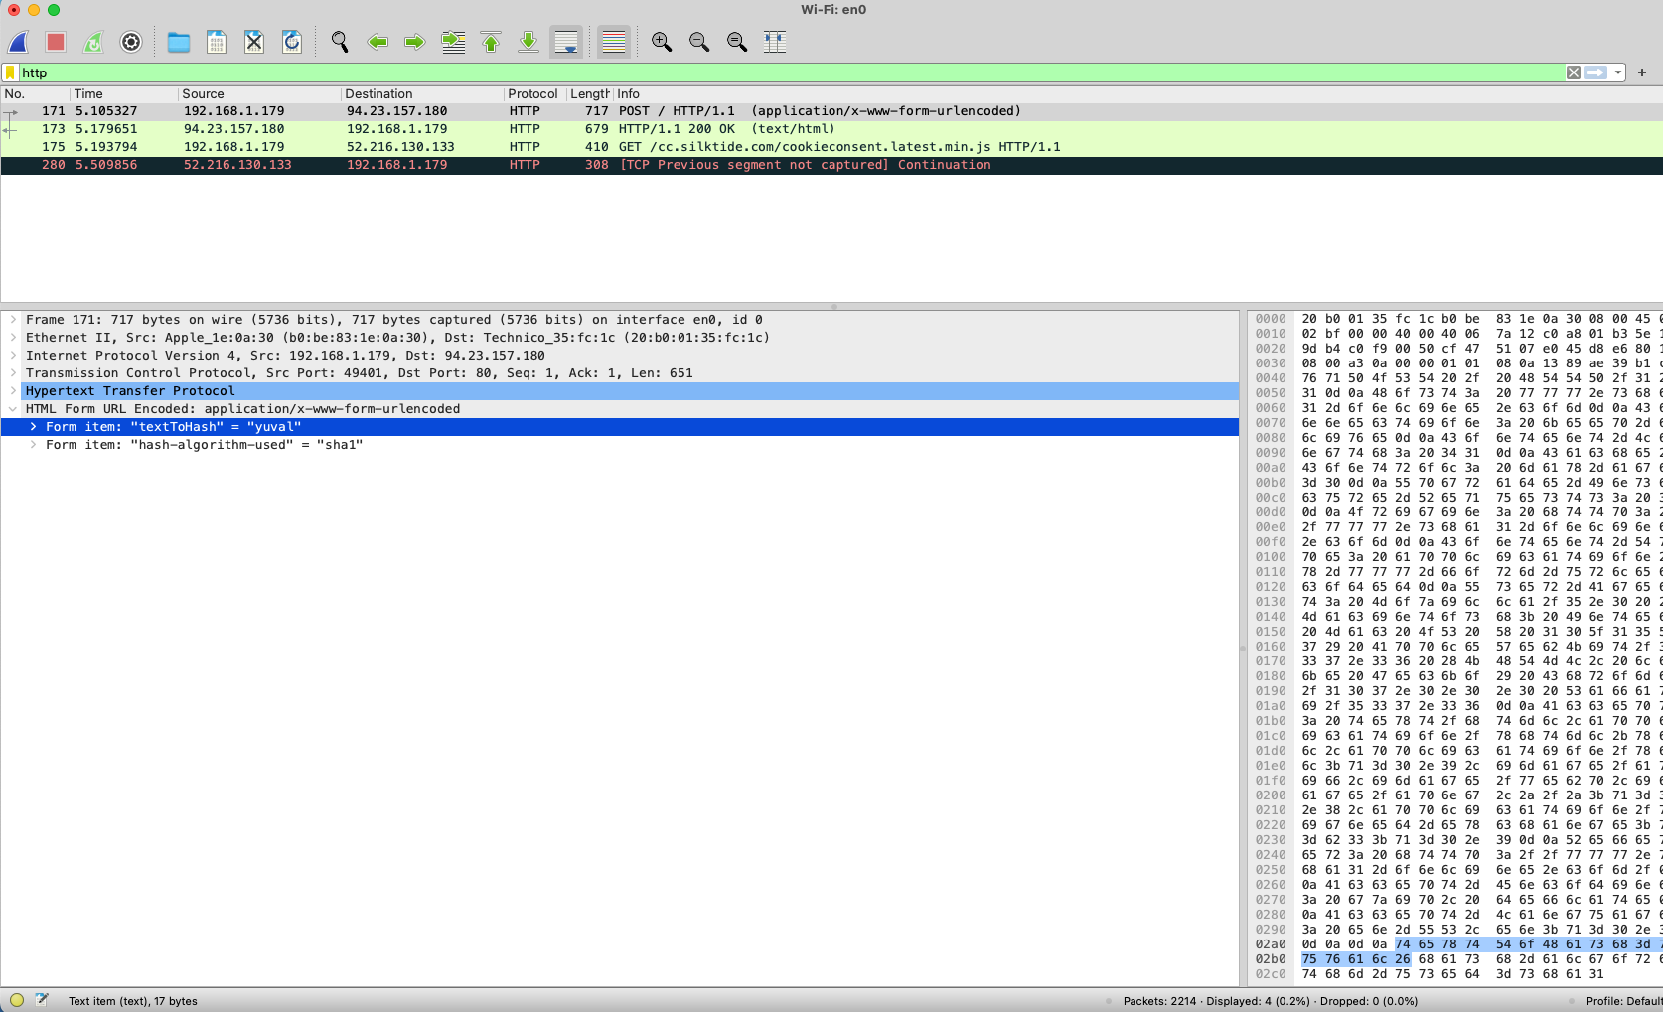

1. As shown in the picture above, the calculation is done on a remote server with the IP address 94.23.157.180.  
   The POST method sends data to the remote server.
2. As shown in the picture above, the name to hash and the type of hashing are the parameters sent in the HTTP request.
3. Because the man in the middle potential risk.
4. A potential risk in such case is a [**man in the middle**](https://en.wikipedia.org/wiki/Man-in-the-middle_attack) attack which general term for when a perpetrator positions himself in a conversation between a user and an application—either to eavesdrop or to impersonate one of the parties, making it appear as if a normal exchange of information is underway.

**Question 11:**There are 3 packets sent from the client and 3 packets returned from the server.

In each package returned text and HTML files.

**DNS**

**Question 13**

Server: 2a0d:6fc2:4343:1800::1

Address: 151.101.67.10

Address: 151.101.195.10

Address: 151.101.131.10

Address: 151.101.3.10

**Question 14**

1. There is 1 query and 1 response to the query.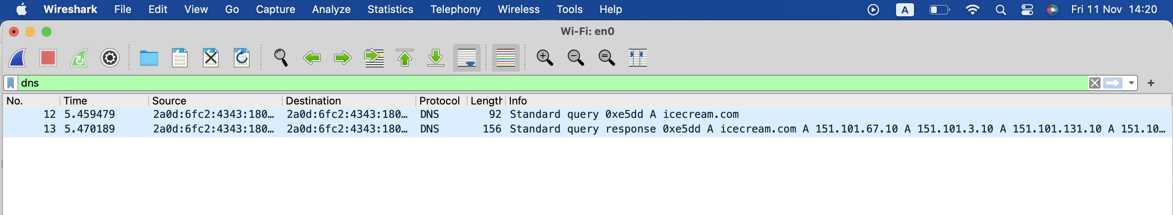
2. There’s only 1 query and 1 response to the query.
3. Port 53  
   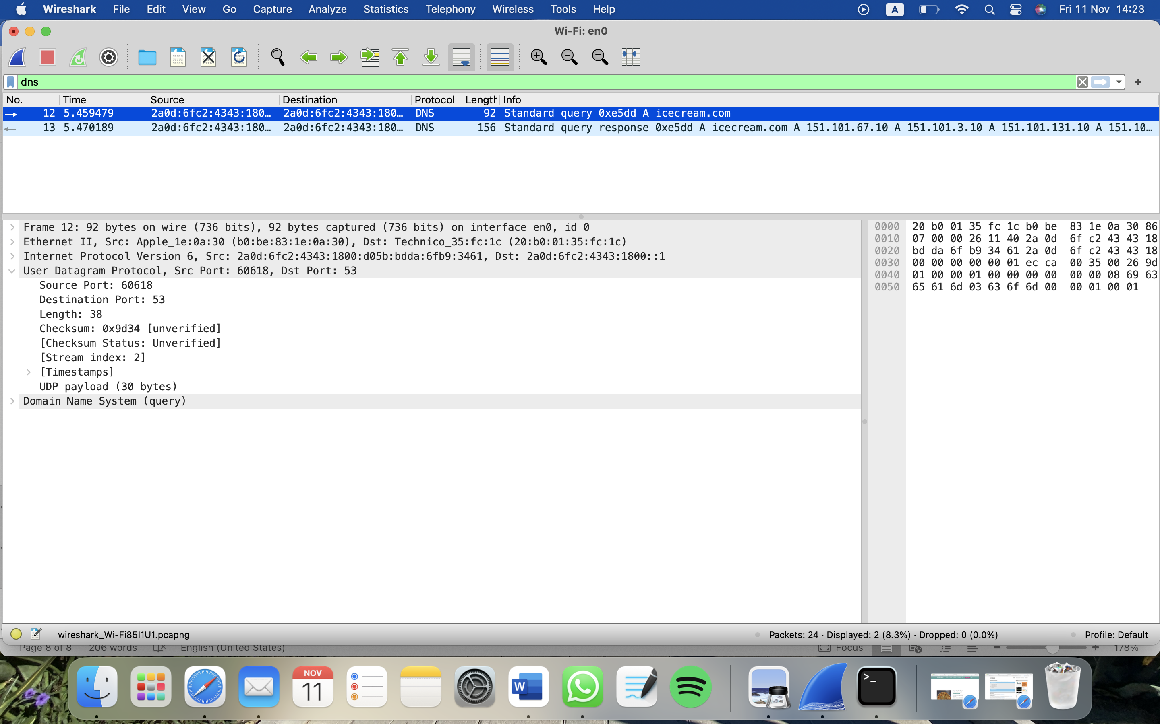
4. UDP as shown in the picture above.
5. The query was recursive – as shown in the picture below “Do query recursively”  
   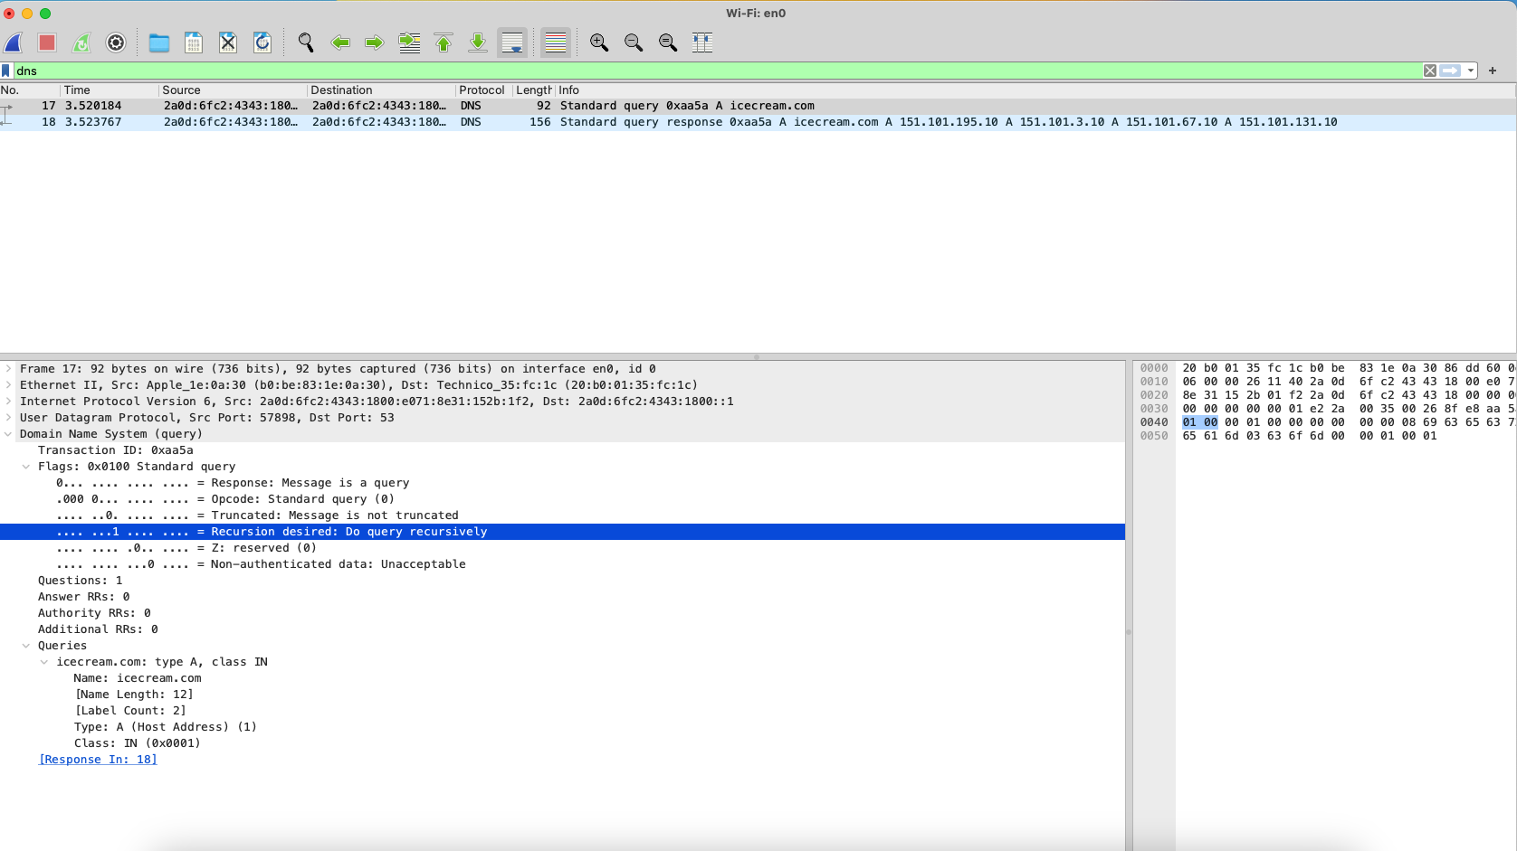
6. The query has 4 answers. The answers are mainly different by their IP address.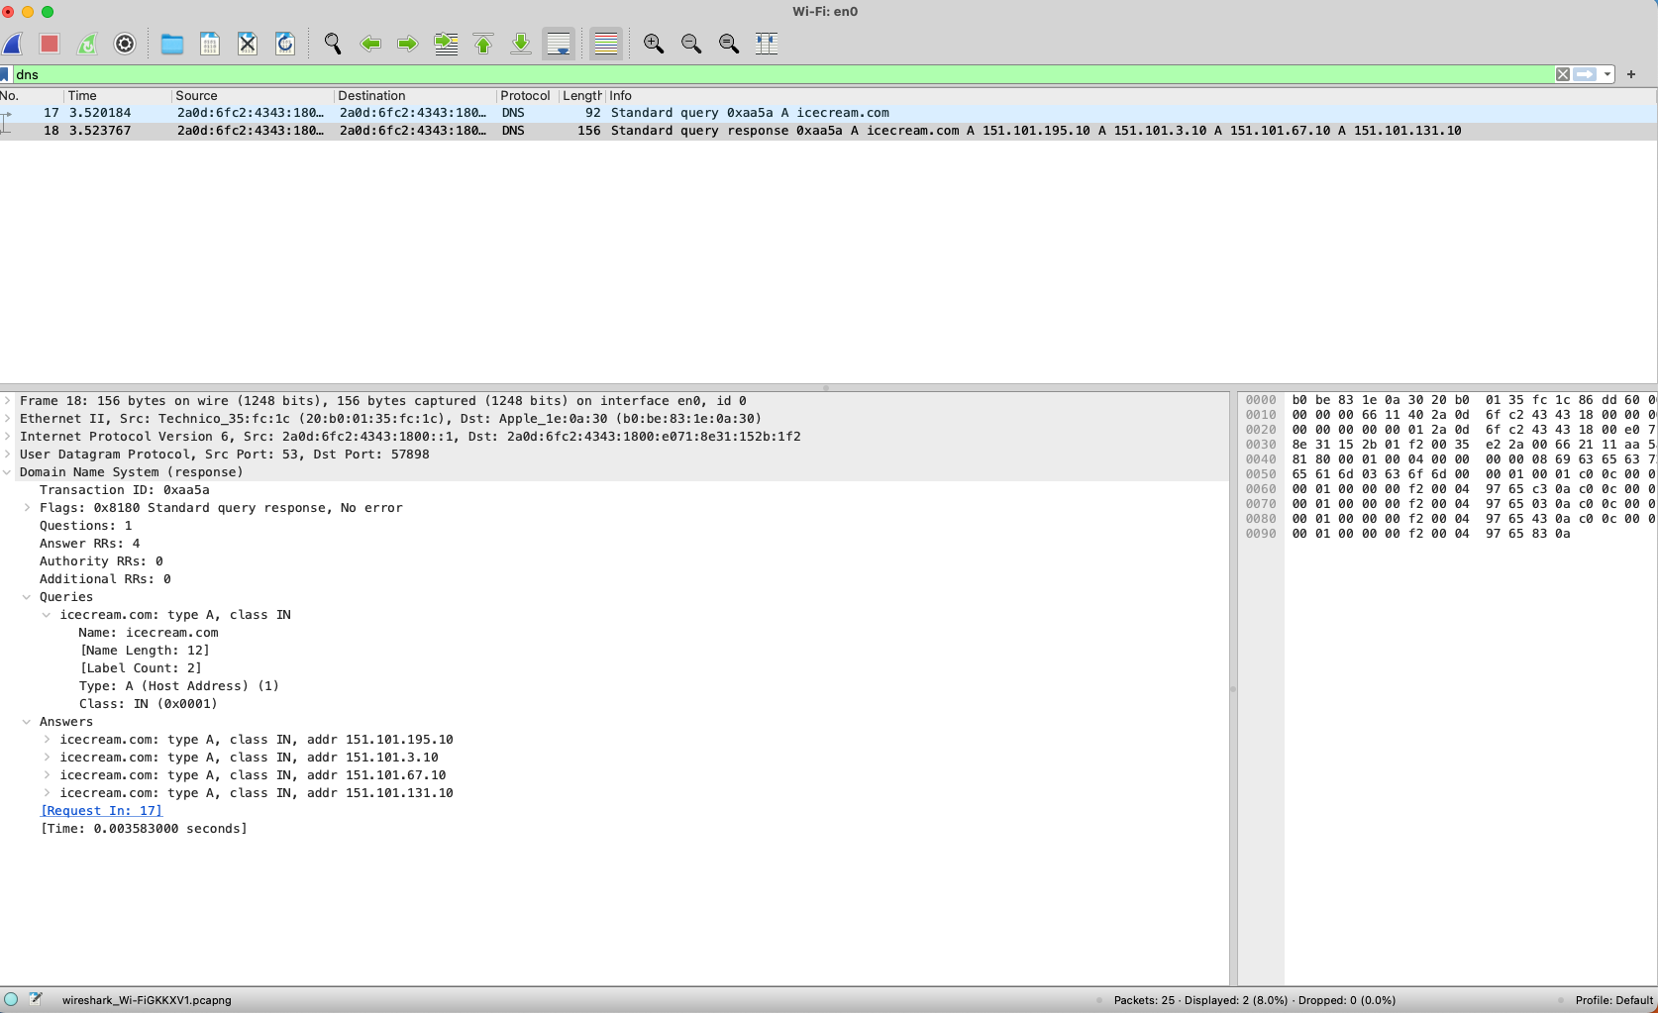
7. A records are used to resolve a hostname that corresponds to an **IPv4** address.  
   AAAA records are used to resolve a domain name that corresponds to an **IPv6** address.

**Question 15:**

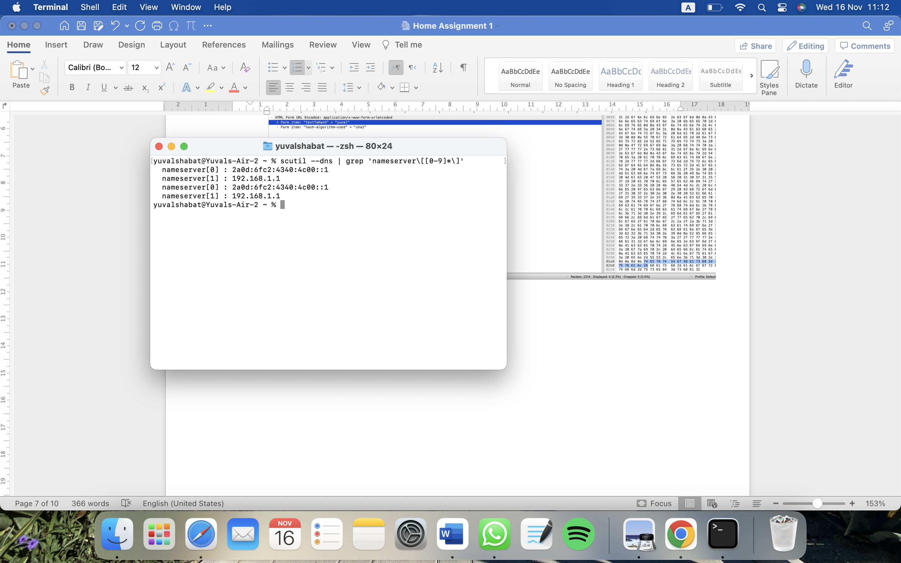

**Question 17:** the results of the DNS server’s address change:

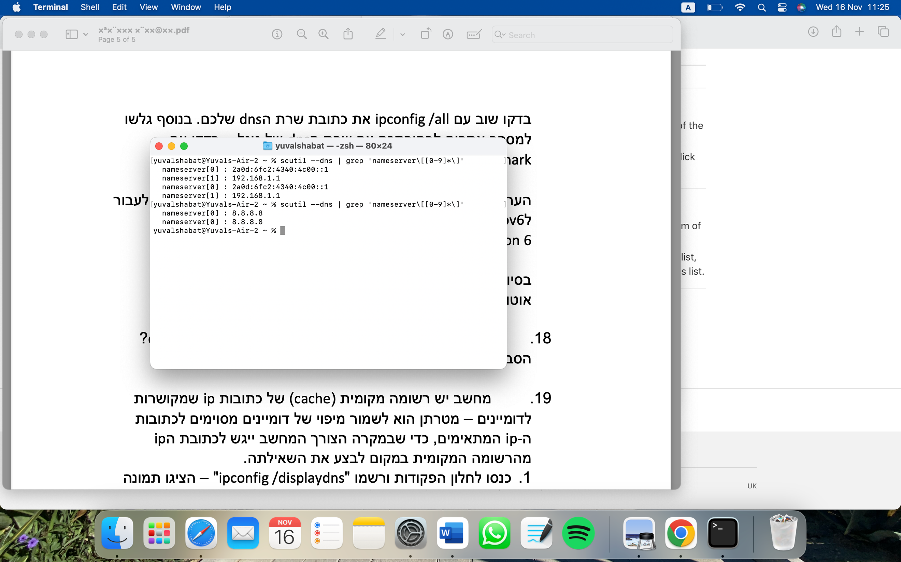

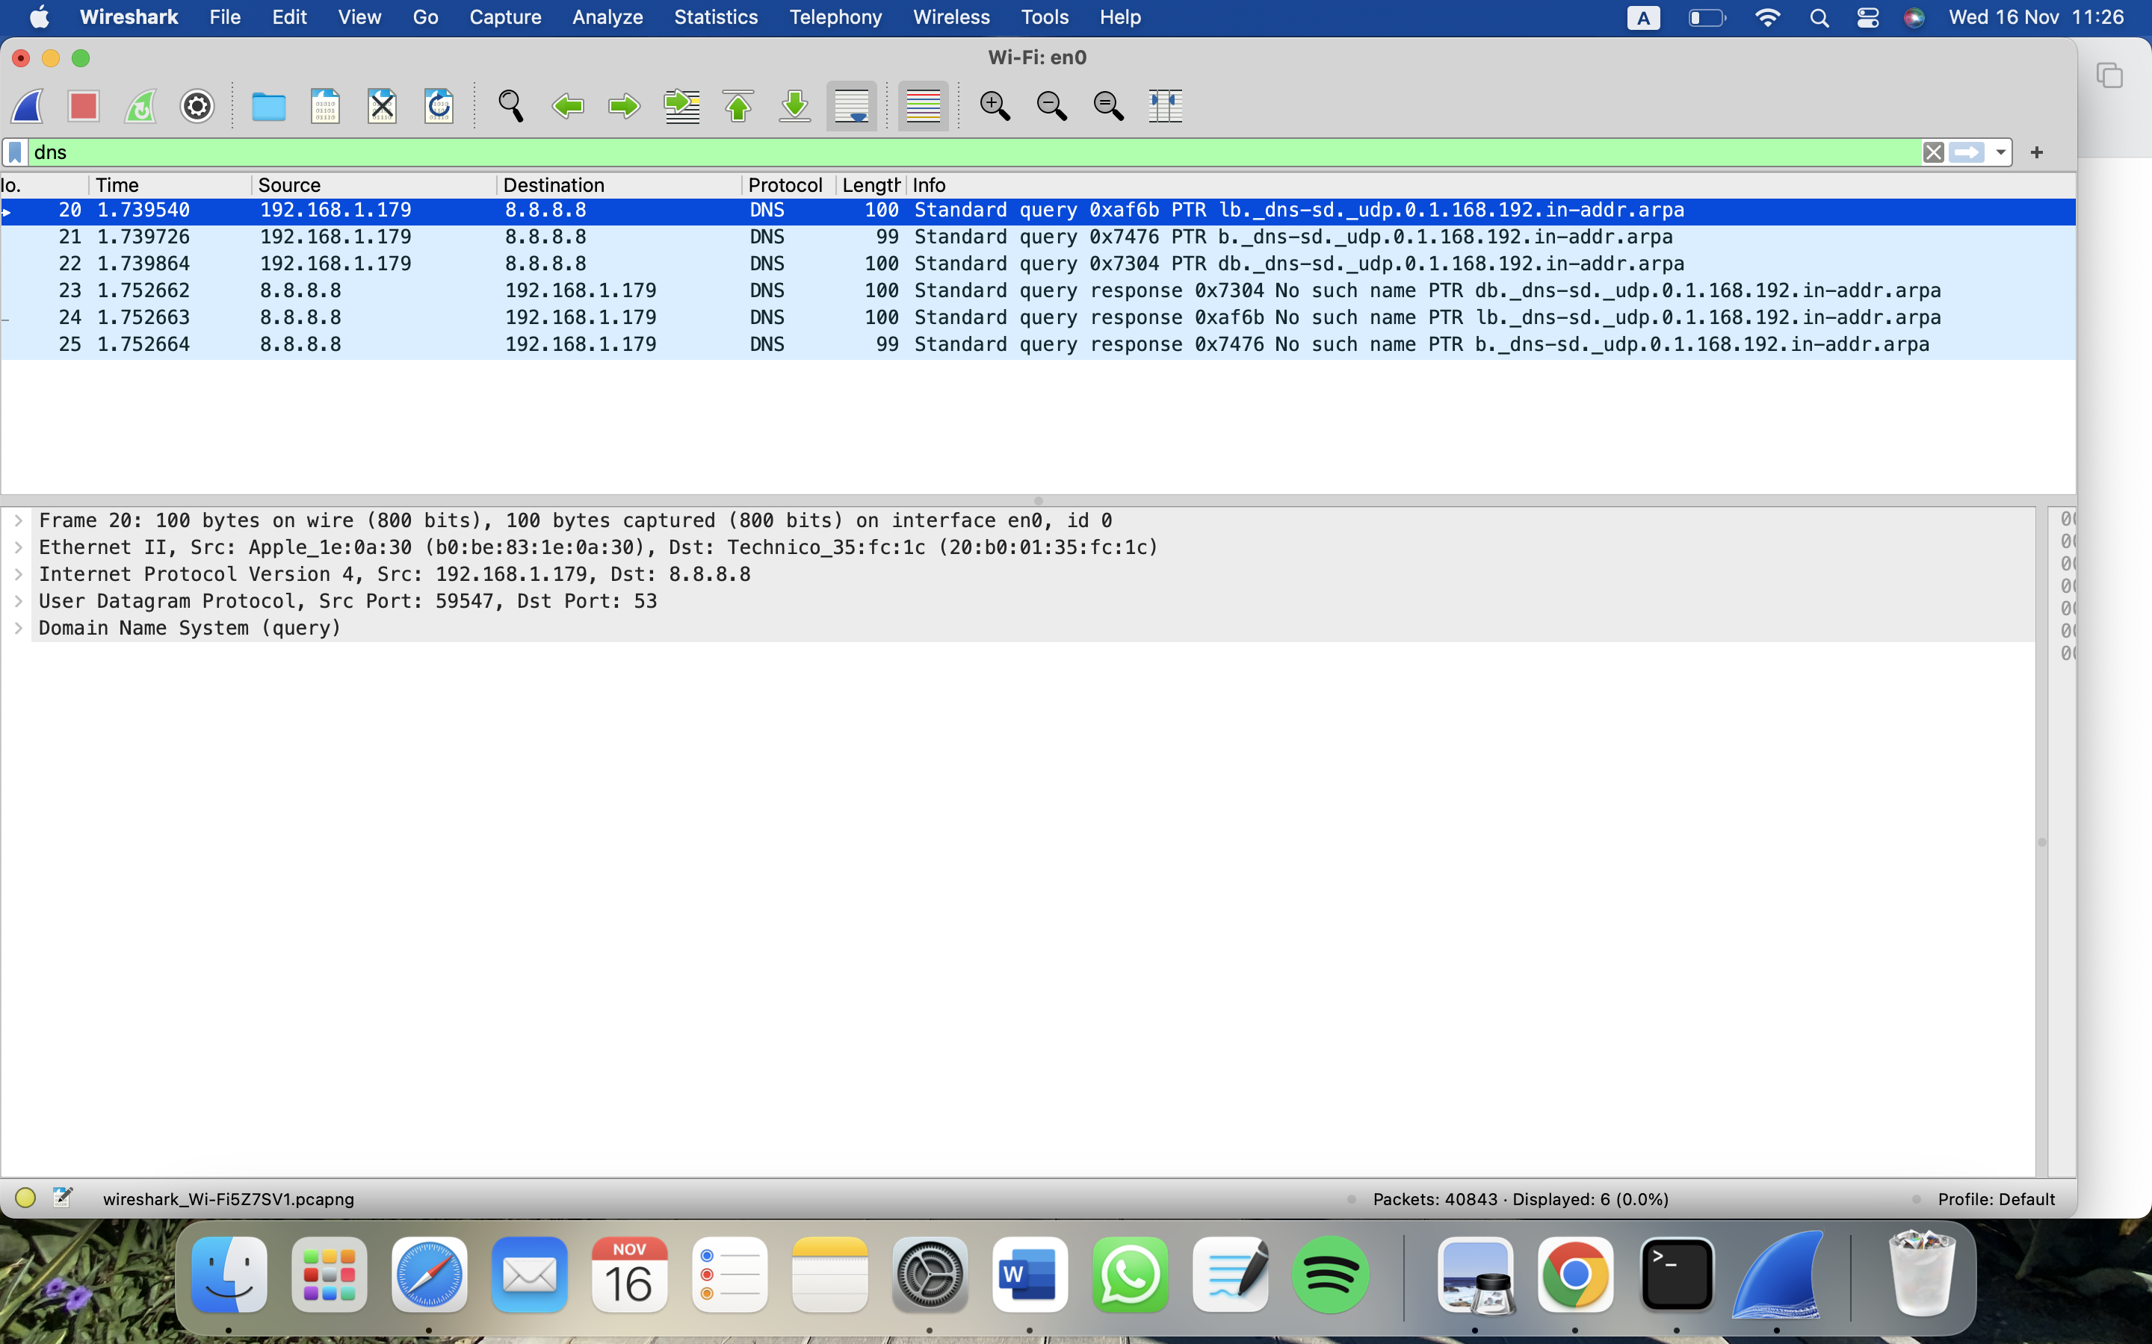

**Question 18:** As shown in question 14.6 the response length is 156 while the query length is 92, therefore a response to a query is heavier.

**Question 19:**

1. 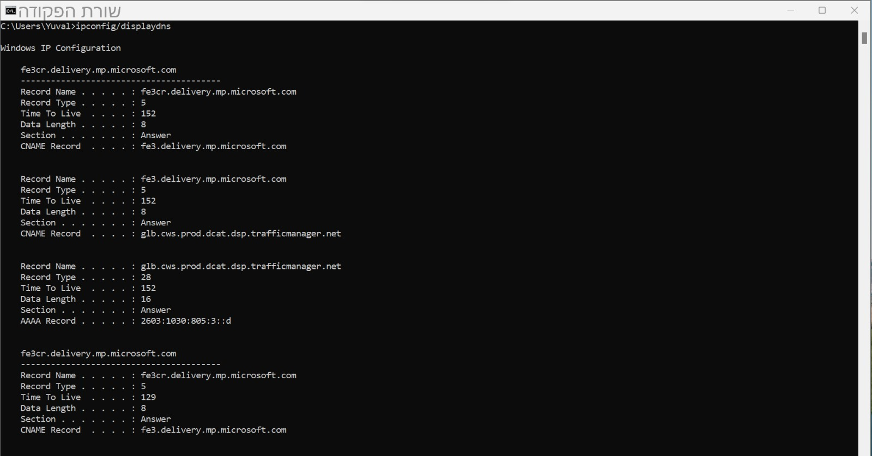

2. 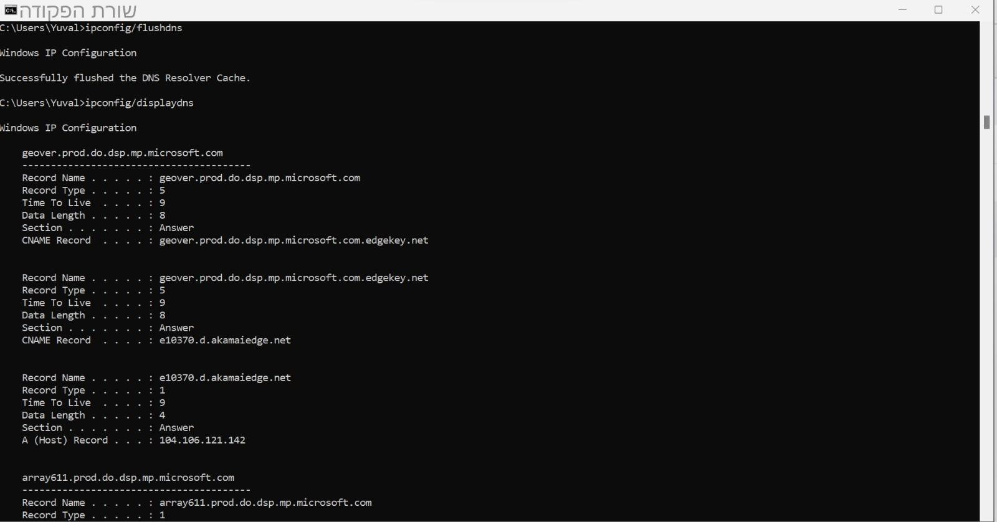

3. As shown in the picture below:

The IP address of icecream.com – 151.101.195.10

Time to live – 58 seconds  
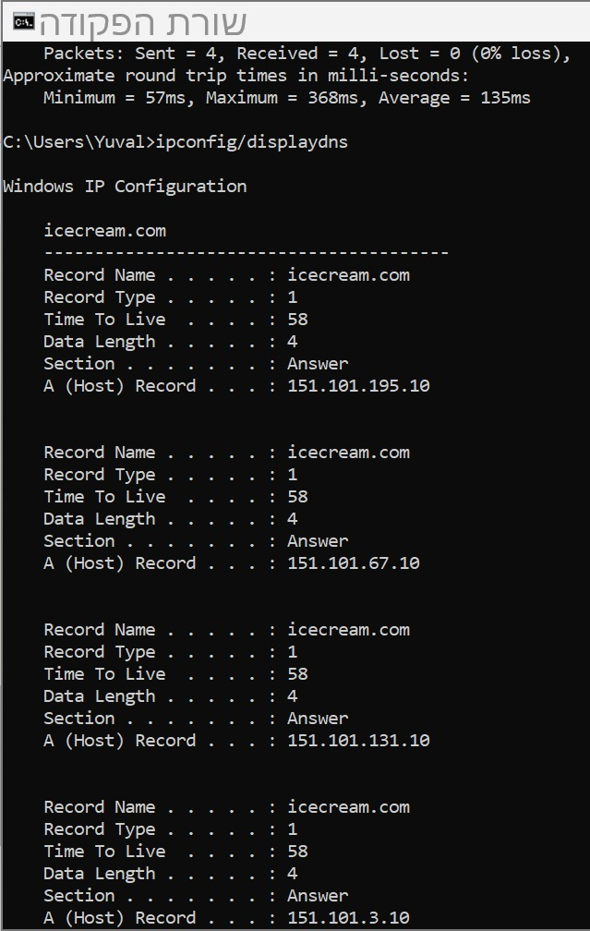

**Question 20:** The browser looks up the IP address for the domain name via DNS and sends a HTTP request to the server.

The server sends back a HTTP response.

The browser begins rendering the HTML.

Once the page is loaded, the browser sends further async requests as needed.